**Analysis:**

In this analysis, we aim to provide insights into the performance and characteristics of various Schools within the district. This analysis envelopes various key metrics such as the average performance of students in math and reading categorized by different grade, size, and type of Schools. We also observed the budgetary information of the schools within the district.

**Conclusion:**

We can draw two main conclusions from this analysis which can then help the school board and mayor to identify the areas for improvement and make strategic decisions regarding future school budgets and priorities:

* 1. While District Schools have a greater number of overall students along with a greater total school budget and per student spending range, Charter Schools still outperform District Schools in terms of overall passing performance.
  2. If the goal of the assessment for the school board and mayor is to consider disproportionately allocating funds to Charter or District Schools based on overall performance of the students, the data would suggest that Charter Schools may offer a better strategic investment as compared to District Schools.

If you look at the overall performance, in aggregate, it appears the Charter Schools have the highest % overall passing metric as compared to the District Schools.

To further break down the data and support this conclusion, you can see from the table below that Charter Schools have a higher average math score 83.9 (~3pts greater than the District Schools), higher average reading score 83.4 (~6.5pts greater than the District Schools).

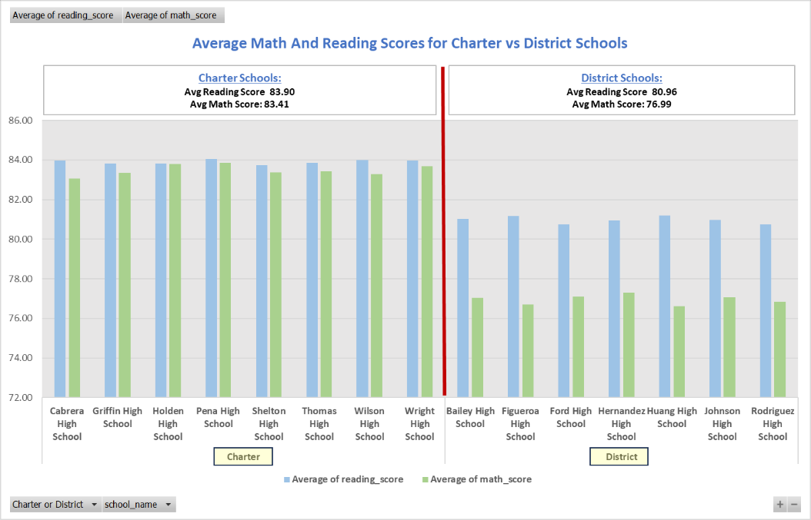



Additionally there are also more students passing math, more students passing reading and more students passing math and reading. As such, with a goal of assessing outcomes and performance of the School Types, as a barometer for budget allocation, then Charter Schools may be the best strategic investment for the board and mayor.